week 5

emmanuel owireku addo

2022-06-24

url <- "https://raw.githubusercontent.com/fivethirtyeight/data/master/police-killings/police_killings.csv"  
need <- read.csv(url)  
#head(need,2)

#let is find the relationship between raceethnicity and gender using maping

ggplot( data = need) +   
 geom_point(mapping = aes(x = gender, y =raceethnicity))

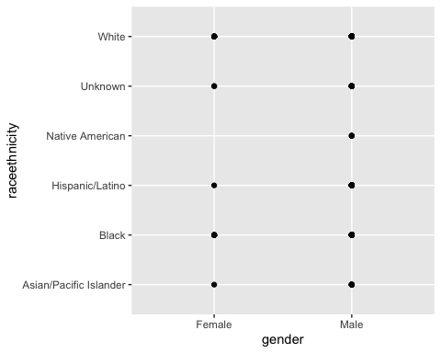

#let us find the gender diffence in count that shows police killing between males and females

ggplot(data = need) +   
 geom_bar(mapping = aes(x = gender))

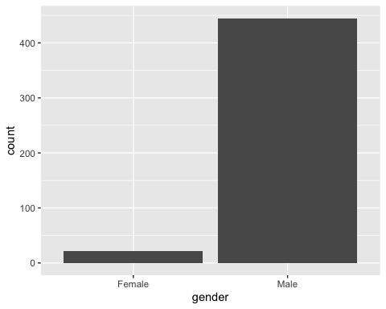 #let us find police killing in each state with their count in household income

ggplot(data = need) +   
 geom_bar(mapping = aes(x = state, fill =h_income))

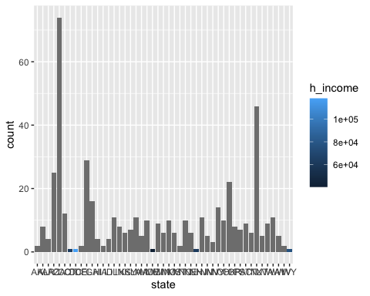 #finding the age range of individuals killed by police in 2015 with what the possesed as threat (being armed or not)

ggplot(data = need) +   
 geom_point(mapping = aes(x = armed, y = age))

